Multitrack test (Magtest)
- Plugin Type: Activity module
- Name: Magtest
- Versions: 1.9, 2.2 to 3.1
- Distribution: Public
- Availability: Stable
- Repository: http://github.com/vfremaux/moodle-mod_magtest
The Magtest activity module is named refering the historical presence of this kind of tests in press magazines. The master process of the test is to dispatch the participant into output categories using a set of multiple score questions, and provide a specific feedback for each category. the magtest is simple configure and use.
What follows is the basic process of the magtest:
The teacher defines a set of output categories. A set of questions will be defined, and an answer proposed for each output category. The student answers by selecting the appropriate answer in the answer set for each question, with no explicit information about the output category associated to the answer. Each category tracks a score. The max score obtained in a category will determine the dominating category.
The teacher can choose if the test can be replayed. Teachers also can weight the answers so they cobtribute more or less to the category score.
Ex: Magtest teacher view
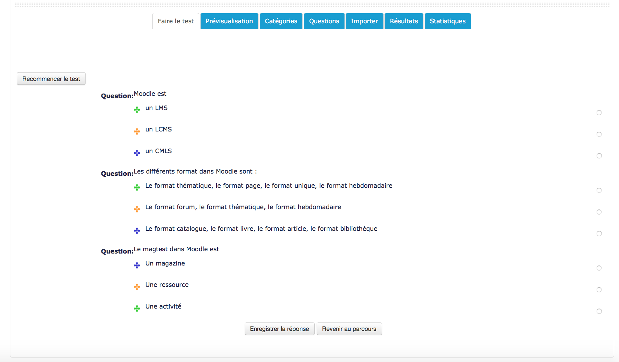

Binary answer mode
In binary answer mode, the student only can answer “yes” or “no” to the question. Answers text is not displayed to users, and all scores are added to the categories depending on their individual weight.

Features
- Test authoring
  - Category management
  - Question management
  - Importing questions
  - Multiple answer mode or binary answer mode
- test execution
  - Preview mode for teachers
  - Attempting the test
  - Watching results

Guides
- Installation guide
- User guide
- Technical guide

Builds
2.7 | 2.8 | 2.9 | 3.0 | 3.1 | 3.2
Travis-ci Continuous integration
Note : Failing status is not necessarily the sign of a non functionning module. It just says that the moodle code standards check are not fullfilling. This is a continuous effort of us rewriting the plugin code to get it compliant.

Credits
- Etienne Roze
- Valéry Frémaux
Return to plugin index
Return to home

