

Learning Time Check Activity Module
- Component type: Activity module
- Name: Learning Time Check
- Versions: to
- Old versions: 1.9, 2.2 to 2.6
- Distribution: dual release, pro and public version
- Availability: Stable.
- Repository (public): http://github.com/vfremaux/moodle-mod_learningtimecheck.


Activity Description
the LearningTimecheck module is an administrative tool that offers a complete solution when learning time must be assessed for academic and administrative reasons.
the module is a deep rework of the community checklist module. The last versions have been heavily cleaned up to focus essentialy on the pedagogic time assessed contract measurement.
Basic concept
The content of an online course provided by moodle contains a set of resources, activities, interactions that are setup to allow a complete teaching/training activity in that working space. This is to be distinguished from the effective pedagogic contract passed between a learning institution and a learner. Using the LTC, the teachers will be able to select what is relevant to feed a formal pedagogic contract from all the course material, and provide an assessment method based on completion of the contract, or time assessment.
the LTC time assessment is based on “credit time allocation”, avoiding all previous debate on the legitimacy of a “measured” connection time which reveals often hard to obtain and justify.
the basic concept is that the acceptable items for a pedagogic contract are resources or activities implying a certain time of work. some learners may spend more, other less, depending on their own past background. This should be not important anymore in the calculation: the key point is given by the following essential question :
- how much time a reasonable learner would have to spend to acquire this knowledge or skill at this reasonable level of acquisition.
One this question has been answered, the pedagogic contract should accept to credit that time to any learner that complies pedagogic requirements of the item, wether it has been faster or slower to get them.
The LTC proposes a way to quantify those credits, calculate an overall pedagogic contract equivalent learning time, assess it and give outputs upon program completion.
how the teacher calibrates the pedagogic contract:
- He selects the mandatory or optional or non relevant elements.
- He quantifies the learning credit time of each element that will be earned y the learner if completion requirements are met.
- Optionally quantifying the mentorship involvement provisional times, if some mentoring resource planning is to be made.
the teacher uses then standard moodle completion conditions to get the resources or activity completed.
the student learns with the online material, achieving requirements as usual. Completions and achievements are collected and will trigger pedagogic contract marks in the LTC.
Teaching admins can monitor the learners state against the pedagogic contract requirements and get all relevant output reports.

Other uses
Ce composant permet un suivi de part et d'autre de la progression pédagogique. Du côté enseignant des tableaux de suivi clairs permettent de connaitre la situation d'un coup d'oeil, et de pouvoir obtenir des informations de détail si nécessaire.
Du côté étudiant, le module affiche une liste de suivi du marquage. Avec certains formats de cours plus sophistiqués (format Page), plusieurs vues alternatives du module peuvent être insérées dans le cours pour générer des indicateurs de suivi immédiatement lisibles.
Sample 1 : Student side view on “page” format
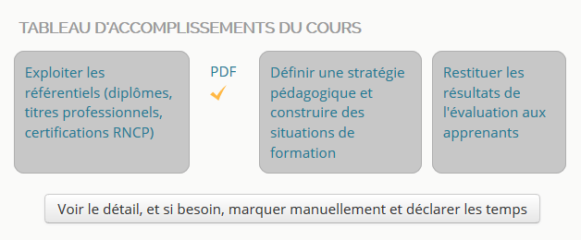
Sample 2 : student ide view on “page” format :
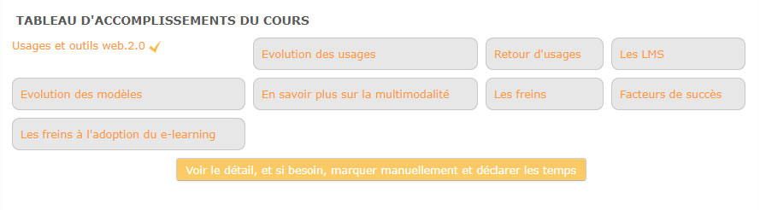

Guides
- Installation guide
- User guide
- Technical guide

Features
Teacher features:
- Define accurately equivalent learning credit time associated to each resource or activity
- Capture all course activities and resources
- Add additional credited entries.
- Reference time for pedagogic contract items:
  - Declared time
  - Credit time (preset)
  - Used with block Use Stats, effective measured time (PRO)
- Ask for declarative time from students
- Declare their coaching spend time (PRO)
- Countermark teacher side the student completion marks
- Monitor progress, group progress, and get reports from progress
- Define coaching time preview
- Get complete report about coaching time hypothesis (PRO)
- Grid marking/monitoring of students
- Global site wide reports (with component report_learningtimecheck)
Student side
- Monitor achievement marks coming from moodle completion
- Declare time when declarative
- Get own report of achievment
Pro version :
- Output tunable PDF reports
- JSON output
- Tutor time anticipation and coaching time reporting
- UseStats and TrainingSessions coupling

Related plugins
- Learningtimecheck block: gives a course wide overview of progress for teachers, reveals longtimenosee students
- Learningtimecheck reports: Provide site wide report capability by course, user (all courses), cohorts, and report generation mass batchs.

Required plugins
- VF Libraries Additional plotting libaries (MIT JQPlot)

Builds
Travis-ci continuous integration
Note : Failing status is not necessarily the sign of a non functionning module. It just says that the moodle code standards check are not fullfilling. This is a continuous effort of us rewriting the plugin code to get it compliant.

Credits
- Valéry Frémaux (valery@activeprolearn.com)- Developments and tests
- Florence Labord (florence@activeprolearn.com) : Documentation and fonctionnal review

Road Map / Work forecasting
- Cleanup the module (pass advanced features to pro version and make basic use simpler)
- Redraw with templates
- Rip off useless code parts from original CheckList

Back to plugins index - Back to catalogue index

