User Guide

Flashcard Module

Setting up the activity
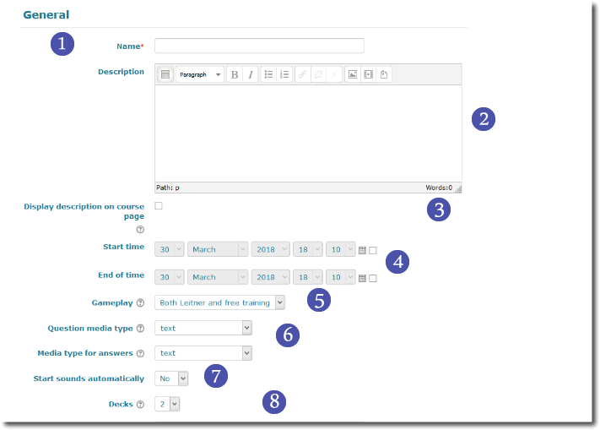

General settings
1. This is the activity name that will appear in the course.
2. Add in the activity intro any information that help students to understand what is the goal of the activity and how to use it the best way.
3. If checked, the intro will be displayed in the course page.
4. you may setup start date and/or end date for the activity.
5. Choose the gameplay, as Leitner, free, or both methods.
6. Select the media type to be used in the front (resp. rear) side of the cards. (text, image, sound, sound and image, video clip)
7. If checked, the media (sound or video) will start playing as soon as the page is loaded. If not, the user will have to start the media clip.
8. This settings defines the number of card stacks that will be used for the Leitner gameplay from 2 to 4. this number may depend on the global difficulty of the domain, and of the number of pairs to memorize. Big knowledge domains may need 4 stacks to enhance the memorisation process.

Review delays
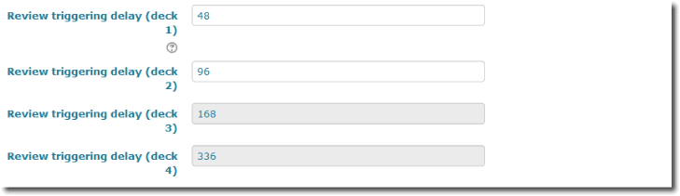
10-11-12-13. Defines the review trigger delay for the card stack. The stack will turn to “has to be reviewed” state after this delay (in hours) running from the last student review.

Notifications
When choosing “yes”, the learner will receive review request reminders after a time you define (the revision delay).

Card customization files
See advanced paramters.

Standard activity settings
As any other plugin, there are a set of standard settings for visibility, activity identification, group and groupment management.

Advanced settings
Advanced settings are usually not visible in the setting form, unless you activate the extra settings.

Deck Erosion Settings
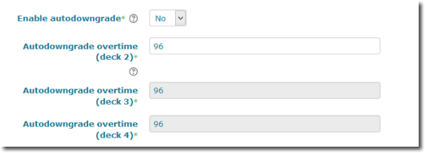
These settings allow you to activate the deck erosion feature, by which cards will migrate back a deck upwards if the autodowngradedelay is expired.
Note: Autodowngrade should be over the review delay or cards may migrate up BEFORE they are reviewed !

Cards customization files
You can add there some images to customize the cardset appearance. Take care the text and players will be printed over the images used in background.
- Front card image
- Back side image
- Empty deck image: Use a dimmed image to avoid confusion with a non empty deck ! This image is used when reviewing a deck to tell the last card has been consumed.
- Needs review image: Will be printed for students in the review interface for those decks that need review (programmed review delay is passed for the current user).
- Reviewed deck image: Printed for those decks that have been reviewed and do not require immediate replay.
- Empty reviewed deck: Printed for thos decks that have no card in and cannot be played.

Extra CSS
Teachers may customize additionnaly cards with a local CSS scriptlet.

Student interfaces
Students just have up to two screens:
- Leitner play
- Free play

Leitner play
In the leitner play;, students are proposed the splitted decks colored according to the review request state. When choosing a deck to review, they will be presented each card (in a random order) to check and self-assess.
Note about Possible cheat: there is no provision of the flashcard to check internally if the student was right or not. flashcard is a self-training activity that implies student adhesion of the exercice rules and objectives. If complete review of the set is a completion goal, hurried students may pass the card through giving a systematic passed answer. clear instructions may prevent this behaviour in most cases.

Free play
In free play mode, students willbe presented the whole cardset randomly ordered and will be proposed to review it without other constraints.

Teacher additional interfaces
Teachers will usually have up to five screens:
- Summary
- Edit cards
- Import some cards

Special features

Deck erosion
Erosion is a punishing feature that will pull the cards up to harder decks if they are not reviewed in the expected delay. Long erosion delays may also be used to make an automated long term reset of the flashcards.

Flipping answers and questions
this simple advanced feature let you revert a card set to flip front with back sides and use the set upside down.
Back to the user guide - Back to the component summary - Back to the plugin list - Back to home

