Course Element Subtype : Pedagogic note
the pedagogic note allows setting in the content flow notes that are intended to help teachers to use the course material. They are usually be written by course authors. The typical case is when a teaching organization centrally edit and build course material that is widely distributed.
As for the note de conception, this element has restricted acces. It is not visible by students in the standard configuration.

Render example in course
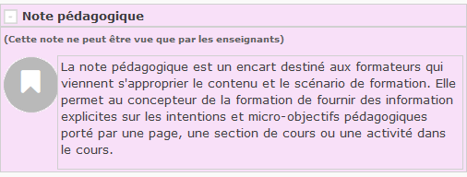

Element instance configuration

General settings (element specific)
- Choose “Pedagogic note” as the element type. (If the element had previous content, an alert will be triggered).
- A new element name is computed if it was empty.
- Enter the note content.
Visible at page load (option)
If enabled, the note will be expanded when course page loads. this may be usefull for very important notices that teachers must read before starting to exploit the course material.
Return to the user guide index
Return to the component index - Return to the common plugin index - Back to home

