The Catalog Class

Moodle Integrated Shop : Structural elements

Introduction
the Shop catalog is a container for managing products sets and bundles, arranged into categories.
Several instances may be used in a master/slave configuration to override some product definitions when required f.e. for feeding different languages in distinct countries, or changing public prices for some delivery regions.

Catalogue typology
A catalog can be :
- standalone (default)
- master, by which it will accept some slaves
- slave, attached to a master catalog, and used to override locally some product information
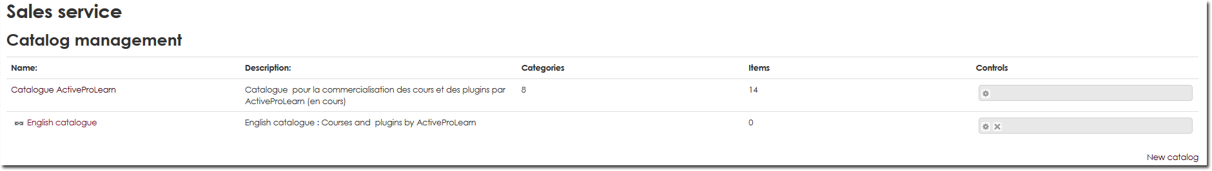

Standalone catalog
This is the most common case for simple sales in a single country / territory.

Master catalog
The master catalog holds the primary category and product definitions. This master definition will preset all the slaves attached to it.

Slave catalog
A slave catalog will be used to override when required some product definitions of the master catalog. there will be no provision to create new products inside, but only redefine some external aspects of the original copy in the master. Product identity and technical parameters will remain identical. Only front office and commercial attributes may be overriden such as price, attached documents, descriptions, etc.
A shop can be assigned to a slave catalog. In that case, the shop will present the master products, overriden by the 'in the way' slave definitions.
Deleting a slave catalog will NOT affect the master catalog. Conversely, deleting a product in a master catalog will remove any slave override attached to it.

Catalog properties
- Name : Catalog internal (back-office) name.
- Description : Catalog internal (back-office) description.
- EULAs/sales conditions : Catalog level EULAs will be presented first and will be appendend with product specific EULAs
- Country code list : You can restrict the country choice list by giving the list of official country codes to use. Each country code has to be separated with comma.
- Bill footer : Le texte de votre choix pour le pied de page de chaque facture du catalogue.
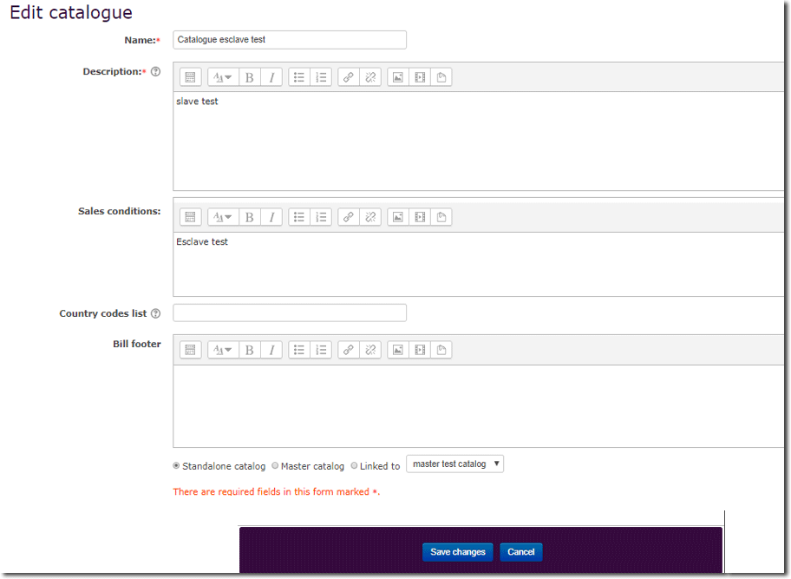

Back to the Moodle Shop structure documentation summary - Go to Configuration and implementation of a commercial offer - Back to Local Shop componant - Back to catalogue

