Back Office : Configuration and implementation of a commercial offer

Define instances of a store
(ou vérifier votre instance de boutique)

Using Shop Access block
Begin by adding the Sales Services block in a course that is used as “customer suppor” or a course of your choice on Moodle platform
Site Administration / Add a Block / Sales Services ( Shop Access)
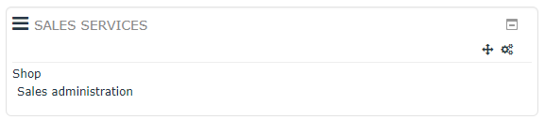
Suivez le lien “Sales adminsitration” dans le bloc Sales Services (component Shop Access)
Folow link “All shops” on Sales Services block.
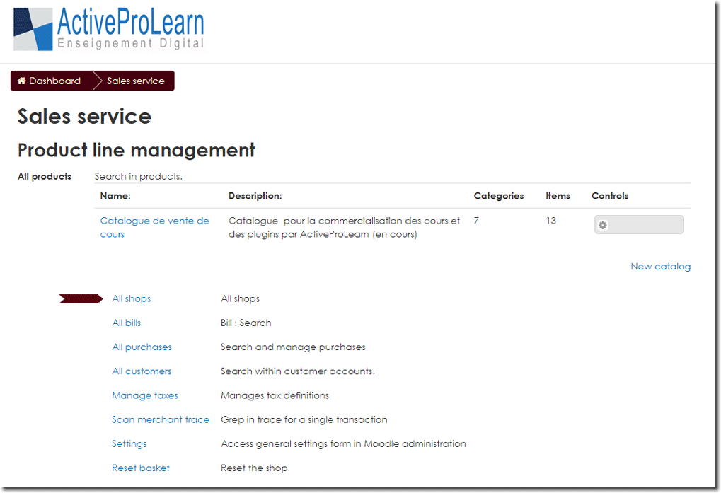
This menu allows you to create another shop instance or change the default one, with its catalog and see how many blocks are attached to each instance.
Finally, click on the “New shop instance” link at the bottom of the table displaying the shop.
To modify an existing shop, click on the toothed wheel at the end of the line of the shop created. To delete an existing store, click on the cross at the end of the shop's line.
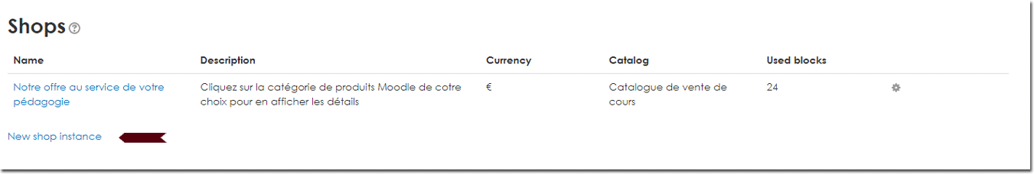{{ :bloc-shop-boutiques.jpg?nolink |
Note: It will be necessary to set the block Shop Access to point it to the desired store instance if you are running multiple stores.

Back to Configuration and implementation of a commercial offer -back to Local Shop componant - Back to catalogue

