Local Shop : General configuration

Introduction
The shop must be generally configured with vendor information in order to operate.
Path: Site administration/plugins/local plugins/shop
The configuration involves four set sections and a certain amount of variable sections depending on the number of payment plug-ins installed.

Global settings
- Default front office navigation: This parameter indicates the sequencing order of front office screens. The shop stores all pre-purchase data during a session. This data can be in a different order according to the business or the wishes of the operator.
Be careful: navigation sequence implicates all front office screens. Some combinations can generate shop malfunctions, such as, for example, attempting to display an invoice before a payment. There are consequently certain rules that need to be followed, notably:
- Differentiate between “pre-payment” screens and “after payment” screens
- Provide the invoice after payment
Pre-payment steps:
- shop : establish the cart
- purchaserequ : collect product parameters
- users : enter information on seats
- customer : collect customer information / existing customer login
- order : order summary
Payment steps (or steps after payment):
- payment : payment or redirect to a payment interface
- produce : digital production of purchased products
- invoice : presentation of invoice or pro forma invoice
- Default currency : Selects the currency given for the shop.
Note : The multi-currency shop operation is planned, but still requires some finalisation. (Utilisation de plusieurs devises dans la même instance de catalogue.)
- Test mode : Si ce mode est activé, alors toutes les interfaces de paiement activées le sont sur les paramètres de bac à sable des différents partenaires de paiement. De plus l'usage de la phase de paiement est interdite aux personnes non connectées et non administrateur. Cependant, les transactions effectuées en mode test généreront des enregistrements effectifs de factures et de produits. Il peut être nécessaire de procéder à une réinitialisation des transactions avant la mise en production effective de la boutique.
- If this mode is enabled, then all payment interfaces are enabled based on the sandbox parameters of the different payment partners. Furthermore, persons who are not logged in or who are not administrators are prohibited from payment phase use. Transactions made in test mode however will generate actual records of invoices and products. Transactions might have to be reinitialised before the shop is actually in production.
- Test lock override : Si ce mode est activé, alors le verrouillage des achats en mode test est levé, pour aller au bout d'une transaction.
- Max items : Determine the max. size of list displays in the back office.
- Hide products if not available : Défaut : No. If enabled, unavailable products (because of checking rules, despite still being advertised for sale) will not be displayed at all. Otherwise, the products will be displayed masked and without the order button.
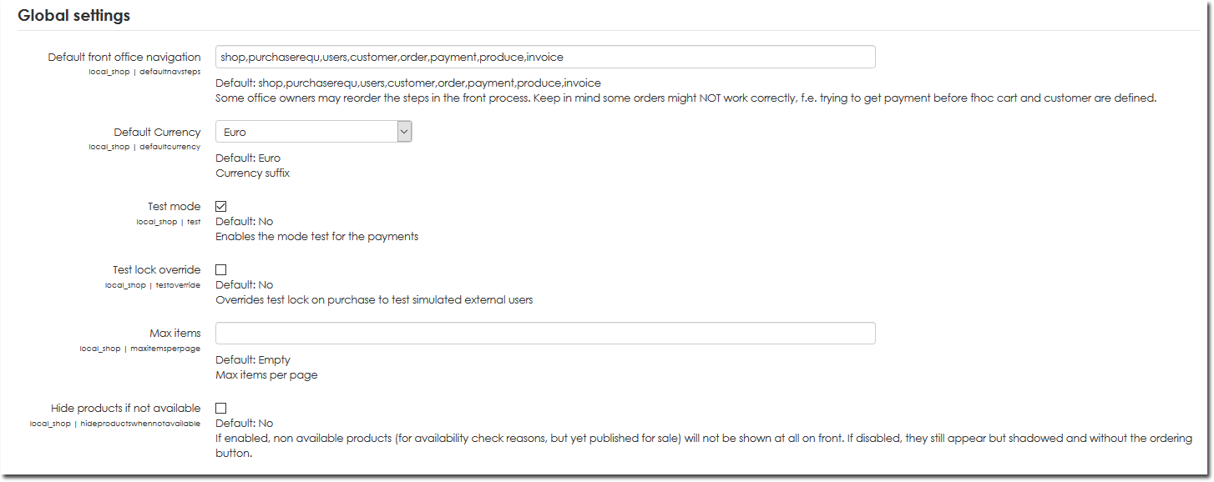

Discount settings
The Moodle shop handles a three-tiered discount system. A discount can only be attributed by logged in users based on certain capabilities at system level.
The discount is applied to the order total and is triggered by a sales threshold. A customer can benefit from a more or less significant discount according to the level of discount they earn by right, but the trigger threshold remains unique. (You cannot tier up different automatic discounts according to cart amount).
To modulate prices according to local quantities with a product, view the settings for a single product. Only one discount threshold can be applied at a time (discounts are therefore not cumulative).
- Discount threshold: This threshold must be provided in current shop currency. Users must have local/shop:discountagreed capability to benefit from it.
- Discount rate: Is expressed as a % of total order amount.
- Second discount rate: This rate is applied to logged in users with local/shop:seconddiscountagreedcapability. You can, for example, create a site role with this capability and have this role attributed via a badge to identify preferred customers.
- Third discount rate: Likewise, a third discount rate can be triggered for local/shop:thirddiscountagreedcapability.
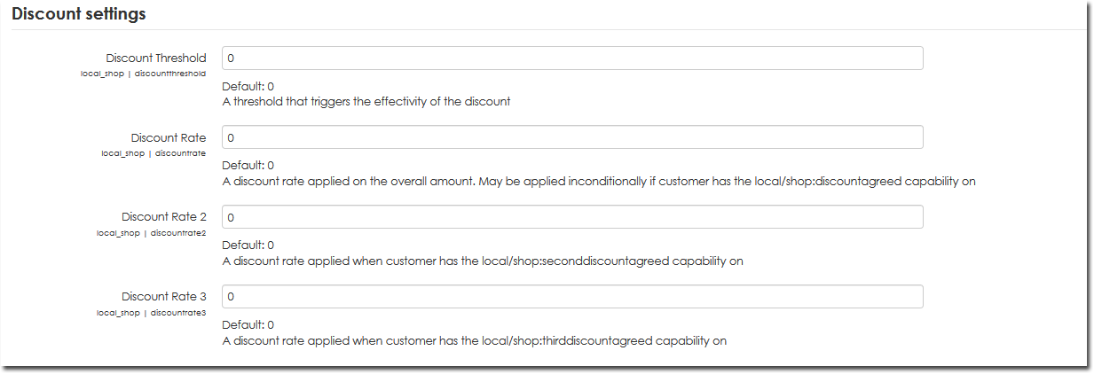

Information about vendor's identity
- Vendor name: Vendor name displayed on screens
- Vendor address: Mailing address displayed
- Postal code: Postal code displayed
- Vendor city/town: City/town displayed on screens
- Vendor country: Country displayed
- Vendor email: Direct email
- Email support: Support contacts on screen or on documents
- Telephone support
Lastly, accounting information is used to display any different data on documents produced (purchase orders, pro forma invoices, invoices, etc.)
- Vendor identifier: Register of business names identifier or any other official vendor identifier.
- Vendor accounts department address: Official address appearing on documents.
- Accounts department postal code: Postal Code appearing on documents.
- Accounts department city/town: City/town appearing on documents.
- Accounts department country: Country appearing on documents.
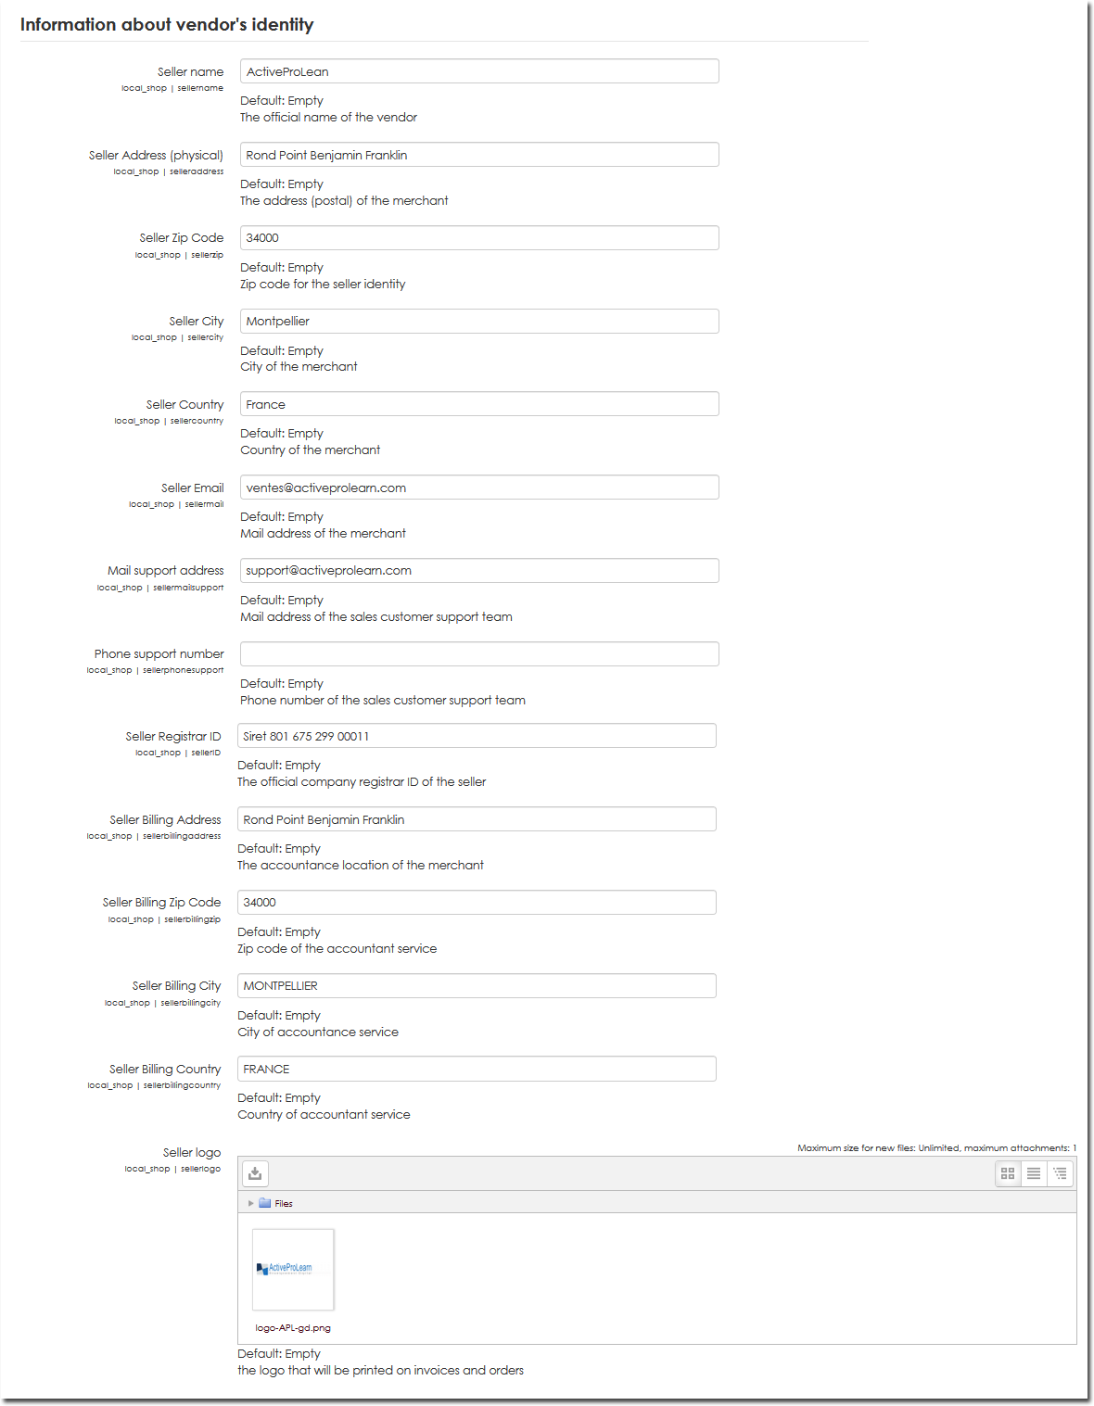

Settings related to payment plug-ins
Each installed payment plug-in can add a set of parameters dedicated to this plug-in functioning. Here are some examples.

Mercanet configuration option
The Mercanet interface is the interface used by BNP and banks in that same group.
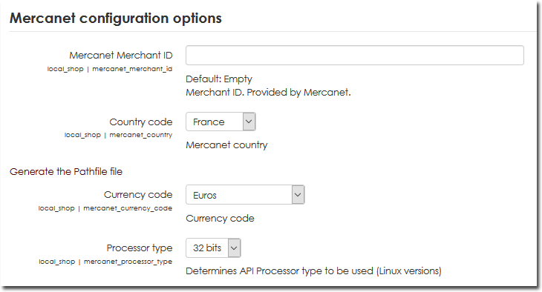

Ogone configuration option
Ogone (now Ingénico), is a multi-bank payment intermediary that can centralise payments received via a unique interface for several different banking systems.
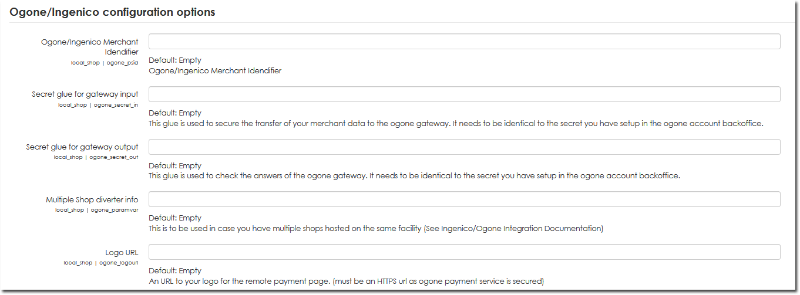

Paypal
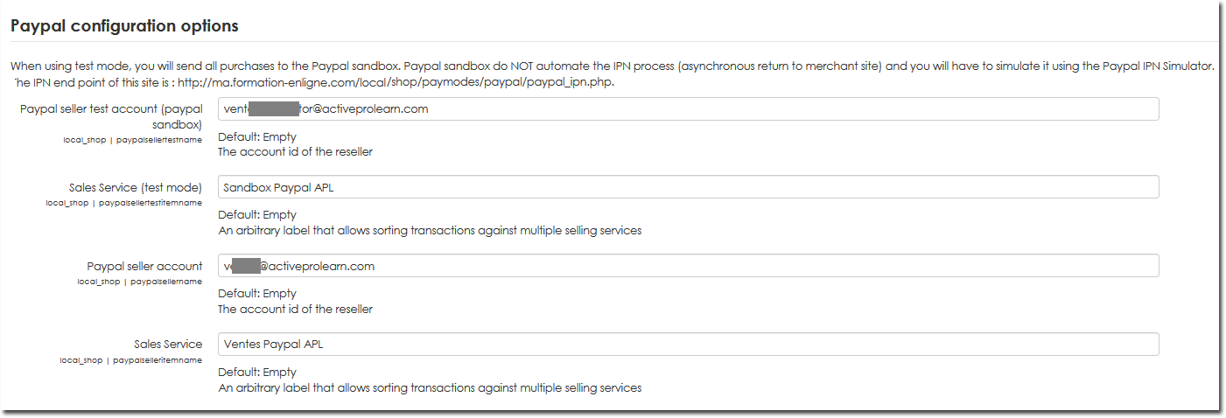

System Pay PLUS
System Pay PLUS, developed by ATOS, is the payment system used by Caisse d'Epargne, the Banques Populaires, and banks in that group.
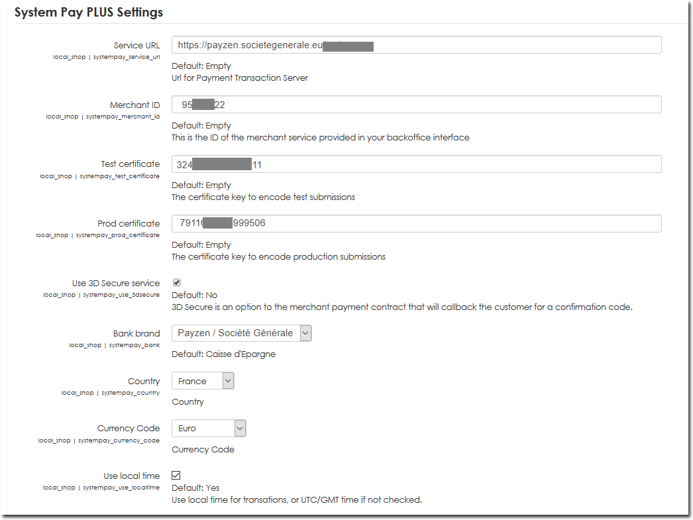

Notifications
- Pre sales notifications : To enable or disable pre sale e-mail notifications
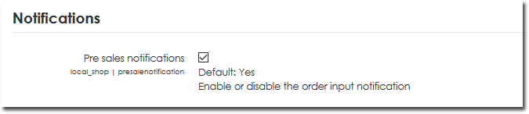

Reseller banking information

Introduction
The vendor’s banking information is used for offline payment procedures to provide bank details for interbank transfers or for issuing cheques. This information is found in your bank documentation.
- Bank name
- Bank code
- Branch code
- Account code
- RIB control key
- IBAN code
- BIC code
- Intra-community VAT number
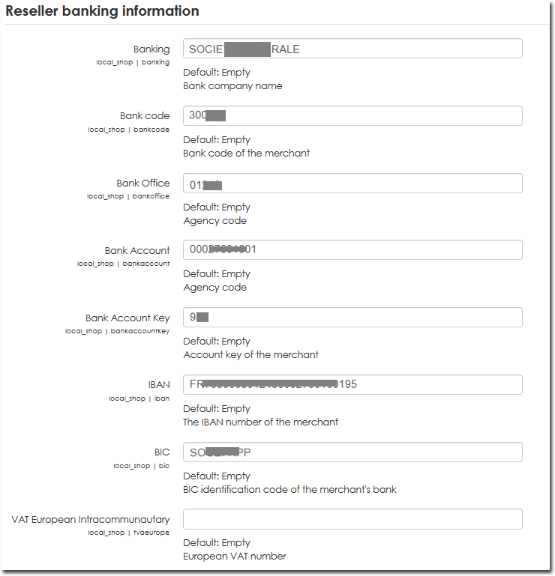

Appareance
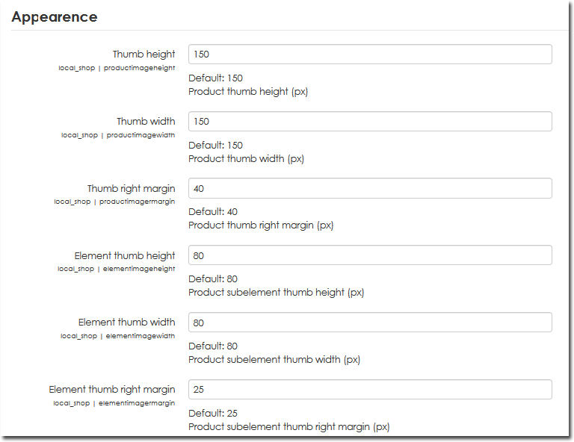

Experimental
These features are enabled but still subject to change.
- Use shipping : Default: No: If enabled, delivery charges are handled.
- Use sales delegation: Default: No: If enabled, users can own products and sell them on their own behalf.
- Use master/slave catalogues: Default: No. If enabled, master/slave catalogues are handled.
- Use renewable products: Default: No: If enabled, renewable products are handled.
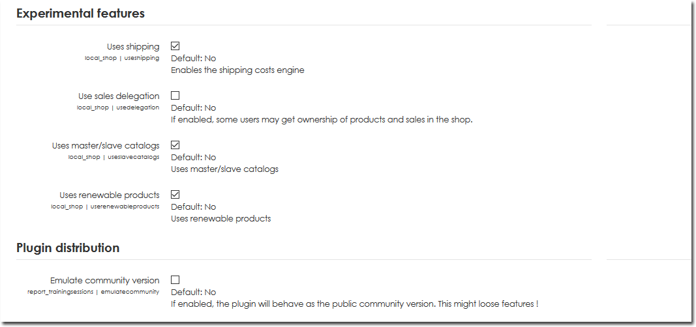

Credits
- Valéry Frémaux (valery@activeprolearn.com) Conception - Developments
- Florence Labord (florence@activeprolearn.com) Revue Fonctionnelle - Tests
back to local shop composant - Back to catalogue

